EGOOLA.COM
Platform Overview
Panels, Core Functionalities, Role-Based Actions, Underlying Data & Process Flows
Multi-Vendor Marketplace & Freelance Services Platform
Revision 4 — every role-based functionality re-verified for completeness against the three companion technical specifications, with the responsible database tables for every feature and a low-level process-flow diagram naming the exact table, column, and before/after value written at every step.
Prepared: August 2026
Document type: Business / Functional Overview

Contents
This list updates automatically in Microsoft Word. If page numbers show as blank, right-click the list and choose “Update Field.”

1. Introduction
Egoola.com is an online marketplace and freelance-services platform built to serve buyers and sellers in Bangladesh. It brings together several different ways of selling — general retail, wholesale, used goods, organic produce, and branded products — alongside a freelance “hire a professional” marketplace, all inside a single website and account system.
The platform is designed around three connected experiences, referred to in this document as “panels”: an Admin panel that runs and moderates the platform, a Seller panel for people and businesses who list products or services, and a Customer (Buyer) panel for people who browse, order, and hire. A visitor who has not registered can still browse the public storefront before signing up.
This revision re-verifies every role's functionality list against the three source-level technical audits produced for this project, adds the specific database tables responsible for each feature, and adds a low-level process-flow diagram for every feature that is a sequence of steps — each step naming the exact table, column, and before/after value the application actually writes, read directly from the source code, so a reader can see not just what happens and in what order but exactly what data changes as it happens.

2. Technology & Architecture Summary
Egoola is a custom-built web application rather than an off-the-shelf store builder. At a high level:
- Foundation: built on Laravel, a widely used and well-supported web application framework (PHP-based), with a MySQL database. This is a mature, production-proven technology choice used by a large share of business websites worldwide.
- Payments: supports Stripe for international card payments and bKash for local mobile-wallet payments in Bangladesh, including bKash's tokenized checkout flow for a smoother, app-like payment experience.
- Sign-in options: standard email/password and phone-number-with-OTP (one-time password) registration, plus one-click sign-in through Google and Facebook.
- Real-time features: live chat between buyers and sellers tied to a specific product/service or order, and an in-app notification system for order updates, approvals, and messages.
- Front-end experience: a responsive design (works on desktop and mobile) built with Bootstrap and Vue.js, with reactive, no-page-reload components (Livewire) used for smoother interactions such as filtering and live counters.
- Location awareness: a full country → division → district → sub-district location dataset is used to power delivery-address selection and to let buyers filter listings by area.
The remainder of this document focuses on what the platform does and who can do it, rather than on how it is built — except for Section 9, which reports what a full technical audit found about how faithfully the current build actually delivers this design.

3. User Panels Overview
Egoola uses a single account system rather than separate logins for each role. Every new account starts as a Customer (Buyer); a buyer can then apply to become a Seller, and Administrators are set up separately by the platform operator. The table below summarizes each panel.
Panel | Who uses it | How access is granted
Guest / Visitor | Anyone browsing the site without an account | No sign-up required; browsing and searching only
Customer (Buyer) | Registered users who shop for products or hire services | Automatic, upon registration
Seller | Individuals or businesses who list products or services for sale | Buyer applies with ID & business details; approved by Admin
Administrator | The platform's operating/support team | Set up directly by the platform owner (not self-service)
A single account can hold both Buyer and Seller capabilities at once and switch between the two views — it is not necessary to create a second account to sell.
A note on the Buyer ↔ Seller relationship
Because buying and selling happen on the same account, the platform treats “Seller” as a status a Buyer account earns, not a separate account type. To start selling, a buyer submits an application including personal/business information and a National ID for verification. An Administrator reviews this application and either approves it (unlocking seller features) or rejects it with a reason, which is sent back to the applicant by email or SMS so they can correct and resubmit. This keeps the seller base verified and accountable.

4. Core Platform Functionalities

4.1 Six marketplace listing formats
Sellers are not limited to one style of shop — the platform supports six parallel ways to sell, each suited to a different kind of business:
Format | Typical use
General Products | Standard retail items, including support for tiered/bulk unit pricing
Used Mall | Second-hand / pre-owned goods
Village Products | Organic and rural produce (farming, fresh food, local crafts)
Wholesale Shop | Bulk-order goods with up to three quantity-based price tiers and a minimum order quantity
Retail Shop | Standard shop-front style listings tied to a physical or online shop
Brand Wall | Branded, warranty-backed products
Each format has its own listing page, image gallery, category tree, and delivery details, but shares the same cart, checkout, messaging, and review experience.

4.2 Freelance services marketplace
Alongside physical goods, Egoola runs a “hire a professional” services marketplace with two ways to connect buyers and sellers:
- Direct hire: a seller lists a service with a fixed or hourly price and delivery time; a buyer hires that seller directly.
- Post a job & receive bids: a buyer posts a project describing what they need; interested sellers submit competing bids (price, timeline, and a proposal message); the buyer reviews the bids and chooses one.

4.3 Shopping, browsing & discovery
- Three-level category browsing for both products and services (broad category → sub-category → specific type)
- Location-based filtering by division, district, and sub-district
- Keyword search, “top seller” and “top buyer” highlights on the homepage
- Shopping cart and a “favourites” wishlist
- Bulk-order inquiry form for wholesale buyers to request a custom quote without placing a full order

4.4 Trust, communication & feedback
- Ratings and written reviews for products, services, and sellers
- Live chat tied to a specific listing or order, so conversations stay in context
- In-app notifications for order updates, approval decisions, and new messages
- Seller identity verification (National ID) reviewed by Admin before a seller can go live

4.5 Payments, wallet & commission
- Checkout by card (Stripe) or mobile wallet (bKash)
- A wallet/balance system that records funds and supports refund requests
- Automatic platform commission calculated on completed sales and completed freelance jobs
- Seller withdrawal requests, reviewed and paid out by Admin

4.6 Content & site management
- Homepage banners and sidebar promotional banners
- Editable email templates for account and order notifications
- Static information pages: About Us, Terms & Conditions, Privacy Policy, Refund Policy, Help & Support
- Sitemap and content feed for search-engine visibility

5. Admin Panel — Actions
The Administrator panel is where the platform's operations team runs day-to-day moderation, configuration, and finance. Every subsection below has been re-checked against the source-level Admin Panel Specification; two functionalities not previously listed here — the dashboard and the listing-republish fee setting — have been added, along with the database tables and process flow for every feature.

Reading the flow diagrams below
Every diagram from here on shows each step as a box with the specific database write (or check) that actually happens at that point, read directly from the application's source code — not a generalized illustration. A box's border color shows which branch of a decision it belongs to (e.g. approved vs. rejected, or a manual/alternate path); the tagged line(s) inside show exactly what changes: [INS] a new row is created, [UPD] an existing value changes from one state to another, [CHK] a condition is checked but nothing is written, and [GAP] flags a point where the audit found no code actually doing what the process implies it should.
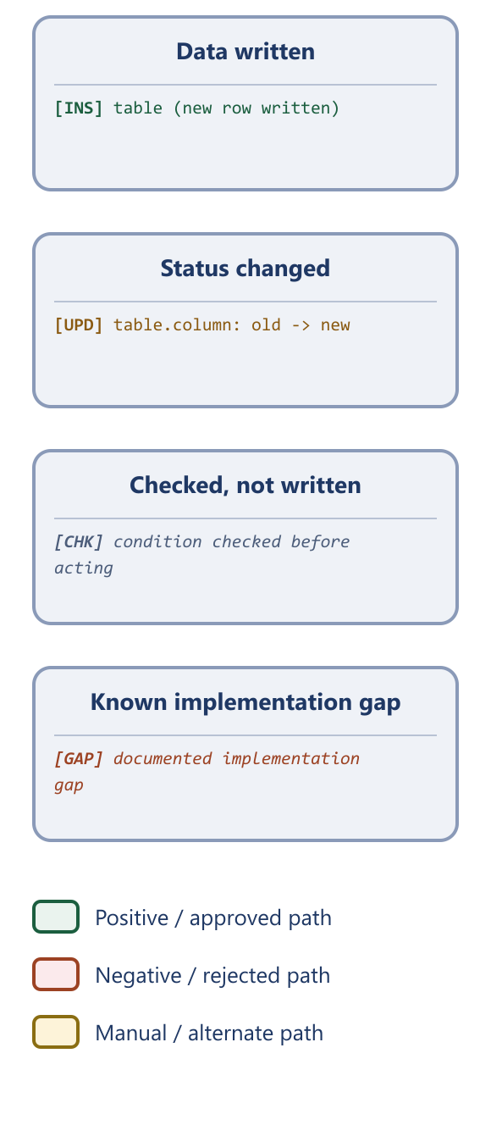

5.1 Dashboard
- View platform-wide activity at a glance on login: total registered users, and total sales recorded for the current month.
Implementation note
Two further widgets (unique visitors, order amount) are present on the dashboard but are currently placeholders not wired to real data — see Section 9.
Database tables involved: users, sales

5.2 Catalogue & content management
- Create, edit, and remove the three-level category trees used for both products and services
- Manage homepage and sidebar promotional banners
- Manage email templates sent to users
- Manage general site settings: logo, site title, login-page banner, and unit-of-measurement list (kg, piece, ton, etc.)
- Set the listing republish fee: the amount a seller must pay to bring a listing they deactivated back to a live status, without going through admin review again.
Database tables involved: grand_categories, parent_categories, child_categories, service_grands, service_parents, service_children, measurements, banners, sidebar_banners, email_contents, others
Category structure (three tiers — the same shape is used for both the goods and the freelance-service category trees):
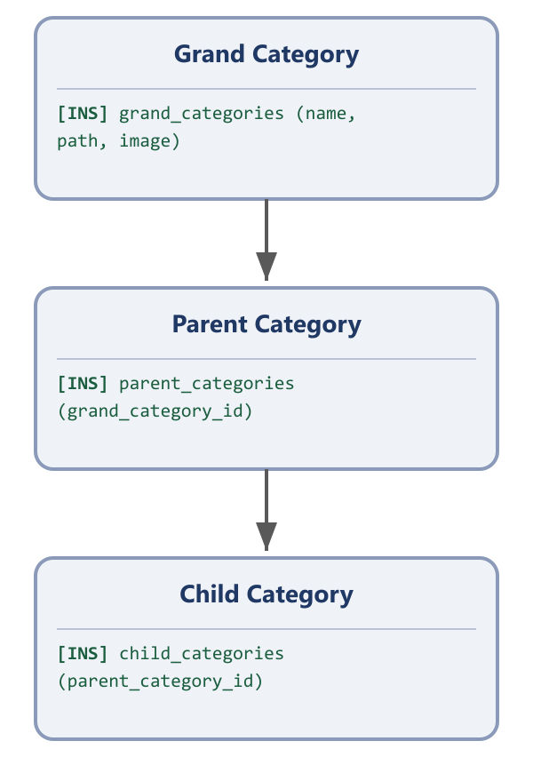
A Child Category always belongs to exactly one Parent Category, which always belongs to exactly one Grand Category.

5.3 Seller verification
- Review the queue of pending seller applications (personal/business details and ID documents)
- Approve an application, which unlocks selling features for that account and notifies the applicant
- Reject an application with a written reason, which is emailed/texted back to the applicant
- Review previously-rejected accounts if the seller re-applies
- Receive a notification the moment a new application enters the queue, or a previously-rejected seller resubmits.
Database tables involved: users, user_infos
Process flow — admin's side of seller verification:
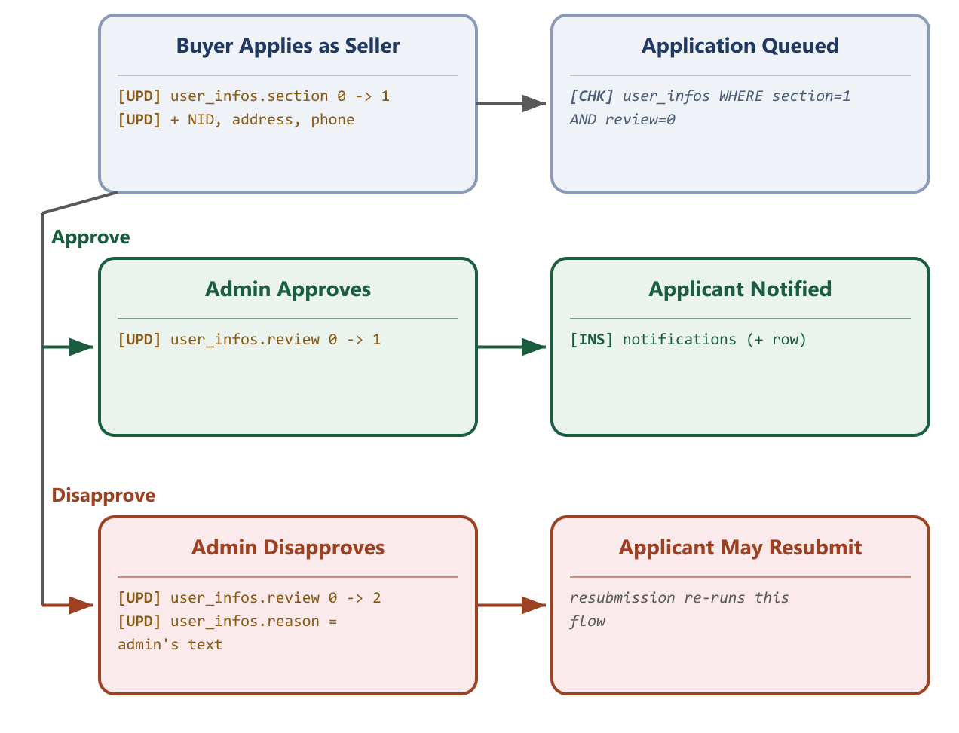

5.4 Listing moderation
- Review newly submitted products and services before they go live on the storefront
- Approve a listing to publish it, or disapprove it with feedback so the seller can correct and resubmit
- View and manage listings that are deactivated (paused by the seller) or previously disapproved
- Separately review and moderate buyer-posted freelance job requests (“projects”)
- Receive a notification whenever a new listing or project is submitted, or an existing one is edited and re-enters review.
Database tables involved: products, used_malls, village_products, wholesales, retail_shops, brand_walls, services, service_orders
Products and services are not moderated the same way
The audit found that product listings and service/freelance listings use the identical status field (approv: 1=pending, 2=deactivated, 3=live, 4=disapproved), but only the service/freelance review screen has a real disapprove action that records a reason and sends it to the seller. Product disapproval is only reachable through a separate, ad-hoc admin toggle that flips the status directly, with no reason captured or sent. The two diagrams below show this difference exactly as it works today.
Process flow — product listing moderation:
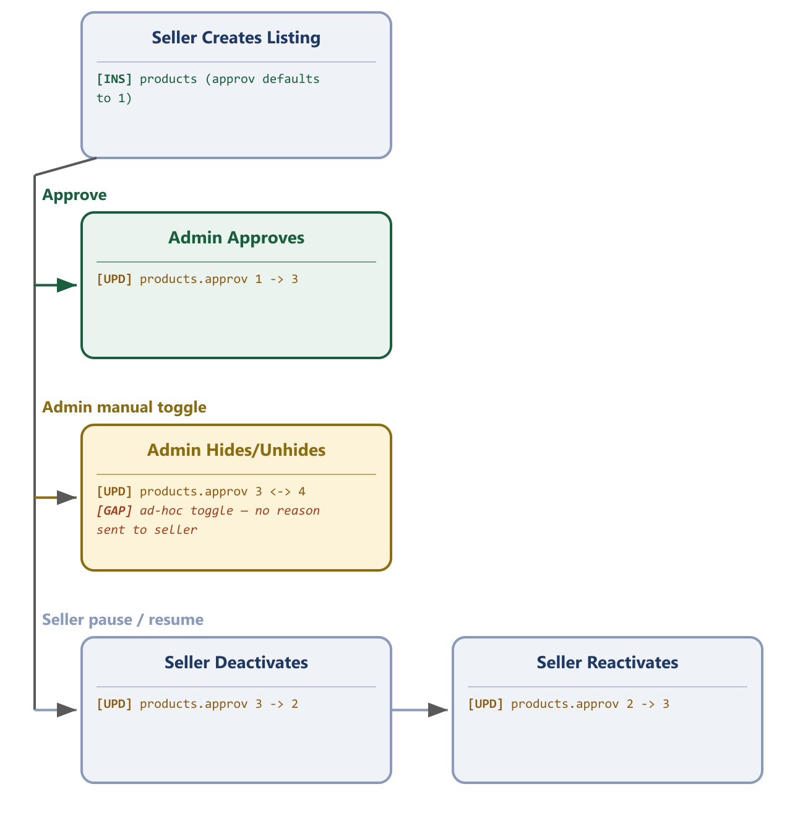
Process flow — service / freelance listing moderation (includes the paid instant-approval bypass):
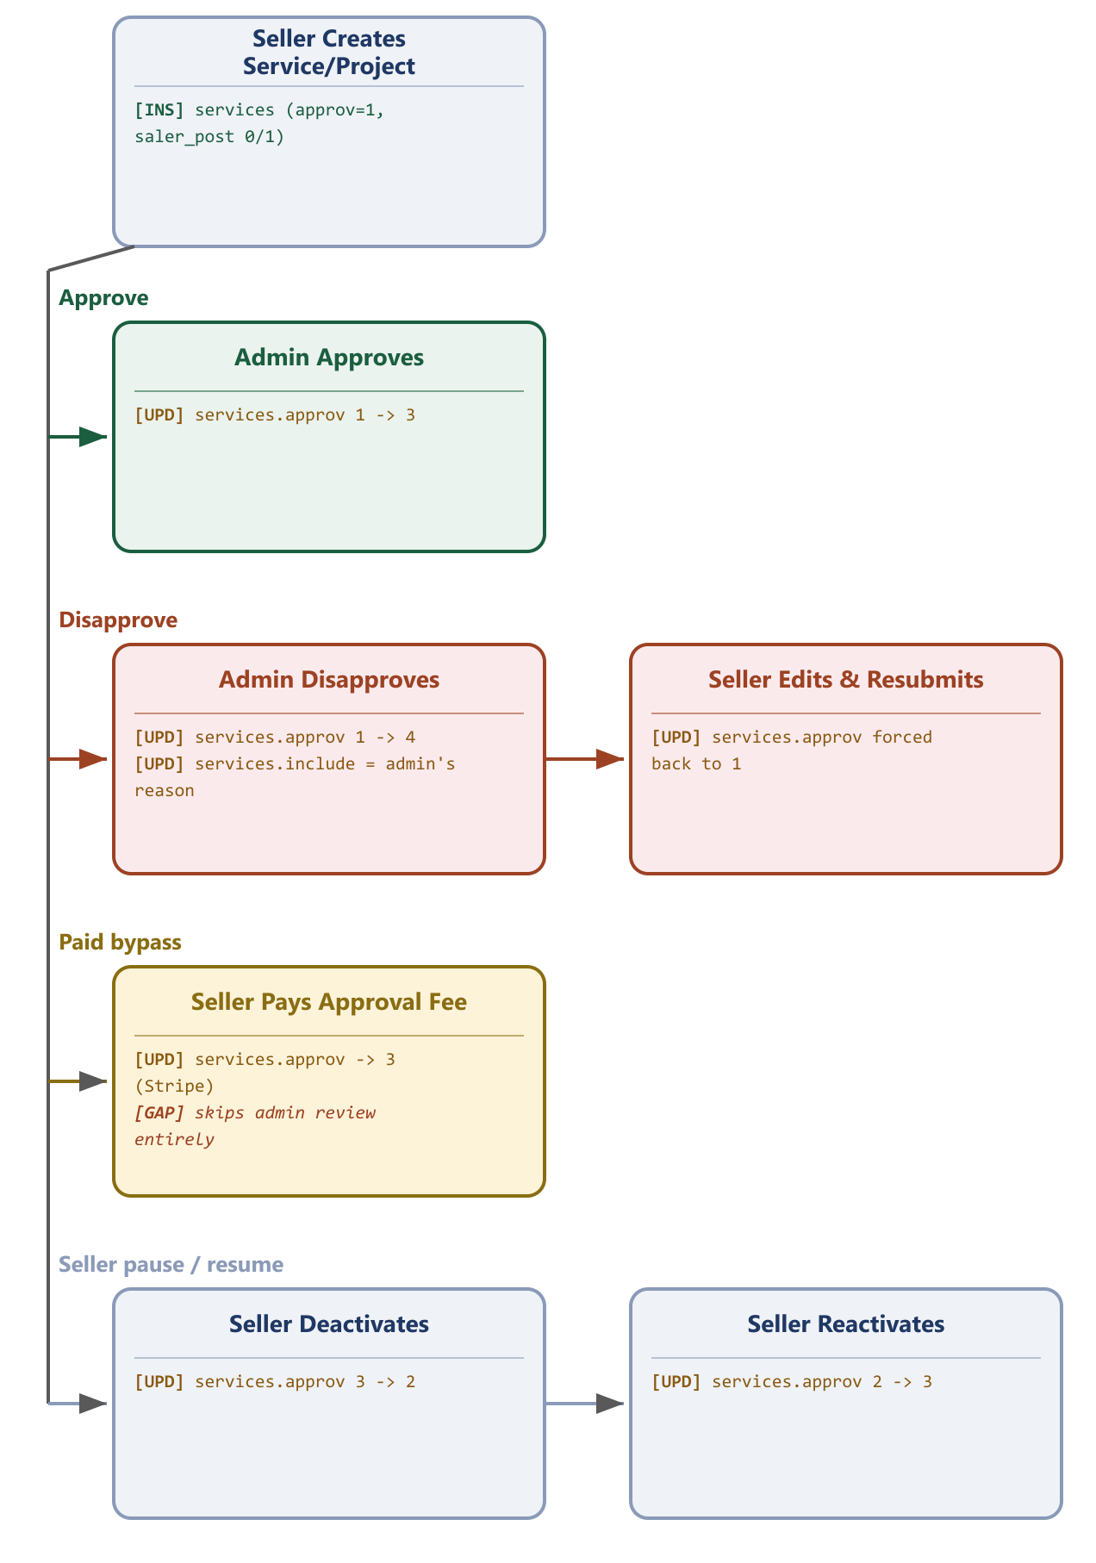

5.5 User oversight
- Search and view all customer accounts
- Oversee active seller accounts and re-review or disapprove an account if needed
- View and, where necessary, cancel freelance service orders platform-wide
Database tables involved: users, user_infos, service_orders

5.6 Finance & payouts
- View the full wallet/transaction ledger across the platform
- Review seller withdrawal requests and mark them as paid once funds are sent
- Review and process customer refund requests, including bKash-specific refunds
- Oversee commission collected from completed sales and completed freelance jobs
Database tables involved: transactions, payment_requests, balances, refund_histories, payments, commissions, commission_payments, others
Process flow — seller withdrawal payout:
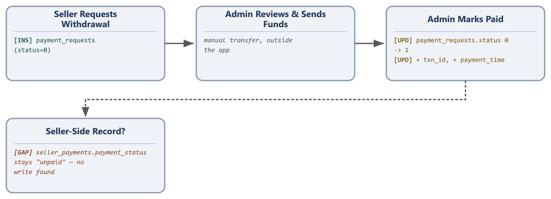
Process flow — refund processing (freelance payments only):
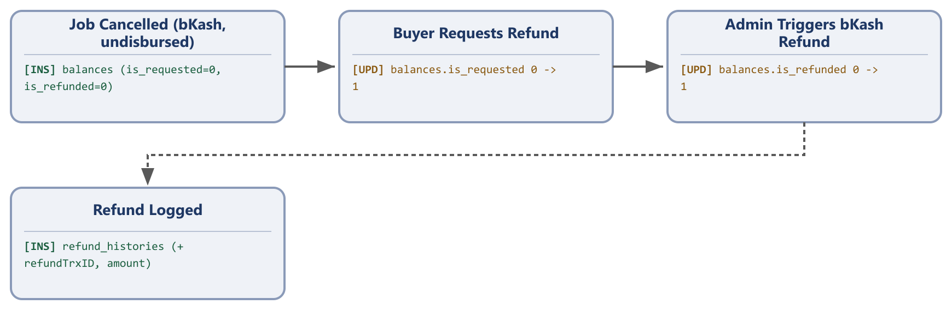

6. Seller Panel — Actions
The Seller panel is available to a Buyer account once its seller application has been approved. Every subsection below has been re-checked against the source-level Seller Panel Specification; a dedicated Notifications subsection (6.8), and richer detail on the personal/company profile (6.1), have been added.

6.1 Getting started as a seller
- Apply to become a seller by submitting personal/business details and a National ID for verification
- Switch freely between “Buyer view” and “Seller view” on the same account
- Set up a company profile: business information, uploaded certificates/documents, and public contact details (phone, WhatsApp, Facebook, WeChat, Skype)
- Enrich the company profile further: add a photo gallery and a short introductory video, beyond the required certificate images.
Database tables involved: users, user_infos, companies, certificats, company_files, contacts
Process flow — becoming a seller (this role's own steps):
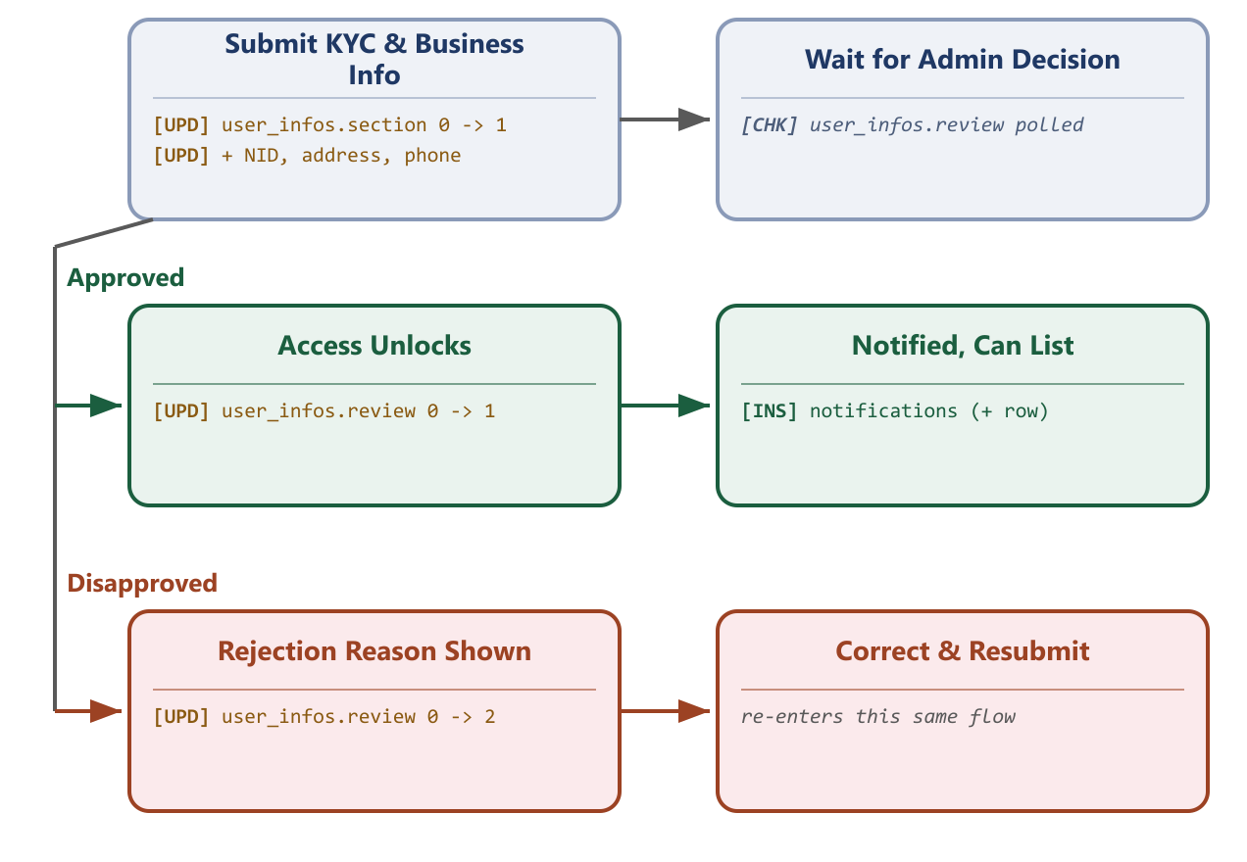

6.2 Listing management
- Create, edit, and manage listings in any of the six marketplace formats (General Products, Used Mall, Village Products, Wholesale, Retail Shop, Brand Wall)
- Create and manage freelance service listings, including price type (fixed or hourly), delivery time, and a portfolio of images
- Activate, deactivate (pause), or permanently remove a listing
- Track a listing's status: under review, live, deactivated, or disapproved (with Admin's feedback)
Database tables involved: products, used_malls, village_products, wholesales, retail_shops, brand_walls, services, grand_categories/parent_categories/child_categories (read), measurements (read)
Process flow — a listing's life from creation to going live:
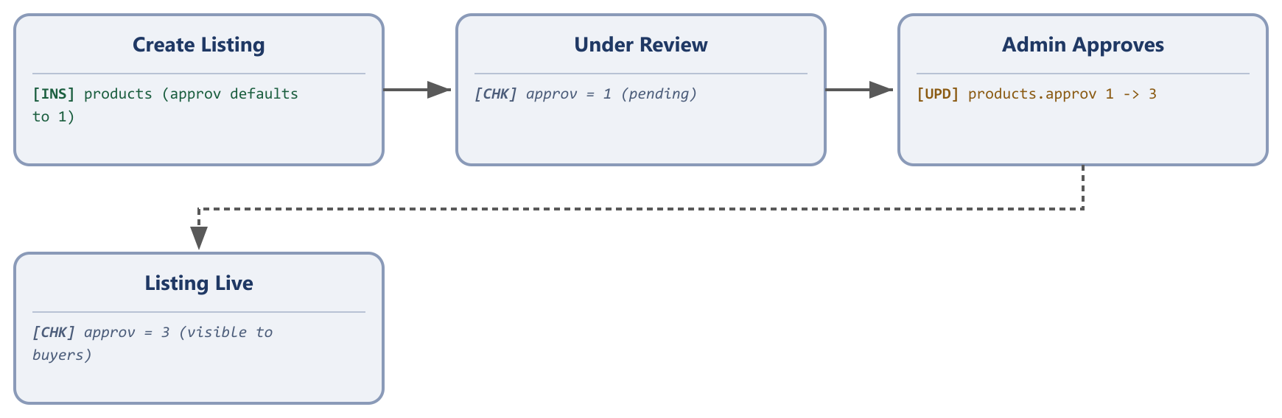
Ongoing management — pausing and resuming a live listing (no re-review needed to resume):
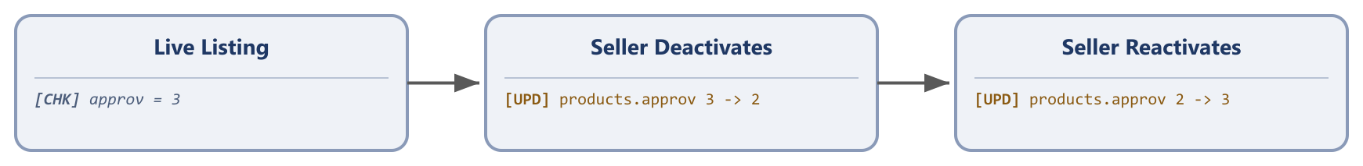

6.3 Orders & fulfilment
- Receive and review incoming product orders and service orders
- Accept or decline an order or a direct hire request
- Mark an order as delivered, and upload delivery files for digital/service work
- Respond to bulk-order (wholesale) inquiries from buyers
Database tables involved: sales, orders, billings, shippings, delivery_costs, service_orders, hireds, hire_pays, order_pays
Process flow — fulfilling a goods order:
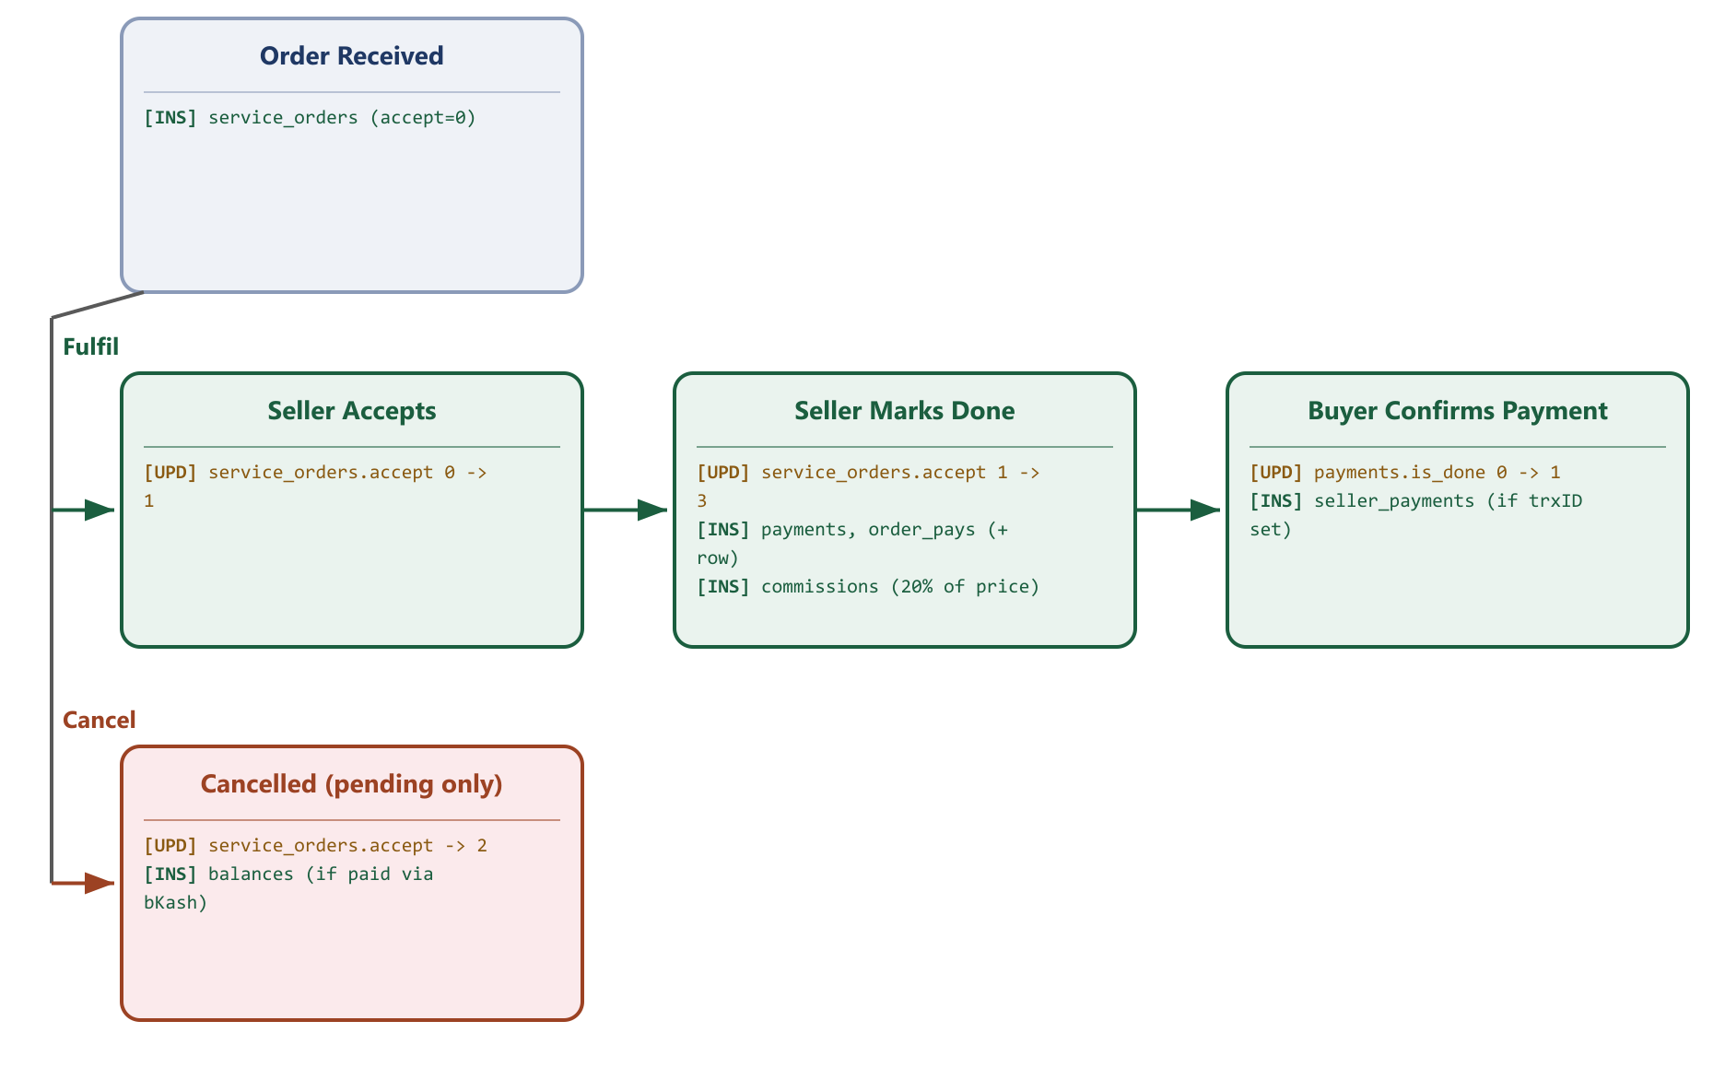

6.4 Freelance bidding
- Browse buyer-posted job requests (“projects”)
- Submit a bid with proposed price, timeline, and message
- Edit a submitted bid before it is accepted
- Accept, decline, or complete a hire once a buyer selects them
Database tables involved: services, bid_for_services, hireds
Process flow — bidding on a project:
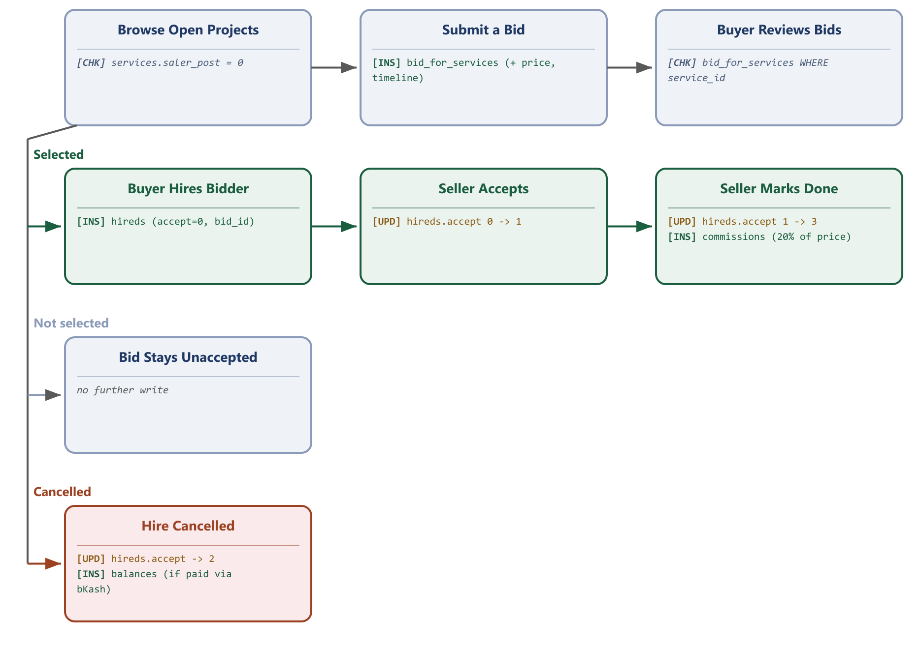

6.5 Communication & reputation
- Chat with buyers about a specific listing or order
- Receive ratings and written reviews from buyers after completed orders
Database tables involved: chats, messages, reviews

6.6 Earnings & finance
- View sales/service revenue and full wallet/transaction history
- Set delivery cost and a free-shipping order threshold
- View and pay the platform commission owed on completed sales/jobs
- Request a withdrawal of available earnings
Database tables involved: user_infos (legacy balance), transactions, payment_requests, seller_payments, commissions, commission_payments, delivery_costs
Process flow — commission payment verification (two real paths — one has a gap):
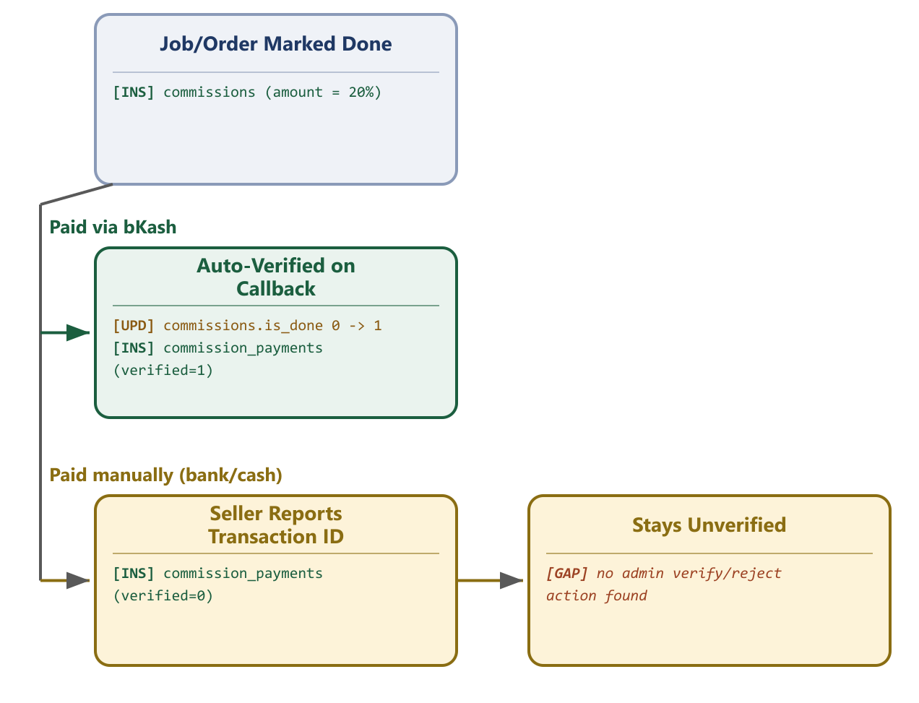
A bKash commission payment is verified automatically by the payment gateway callback. A manually-reported payment (bank transfer, cash) is recorded but the audit found no admin action anywhere in the code that ever verifies or rejects it.
Process flow — from a completed sale to a paid-out withdrawal:
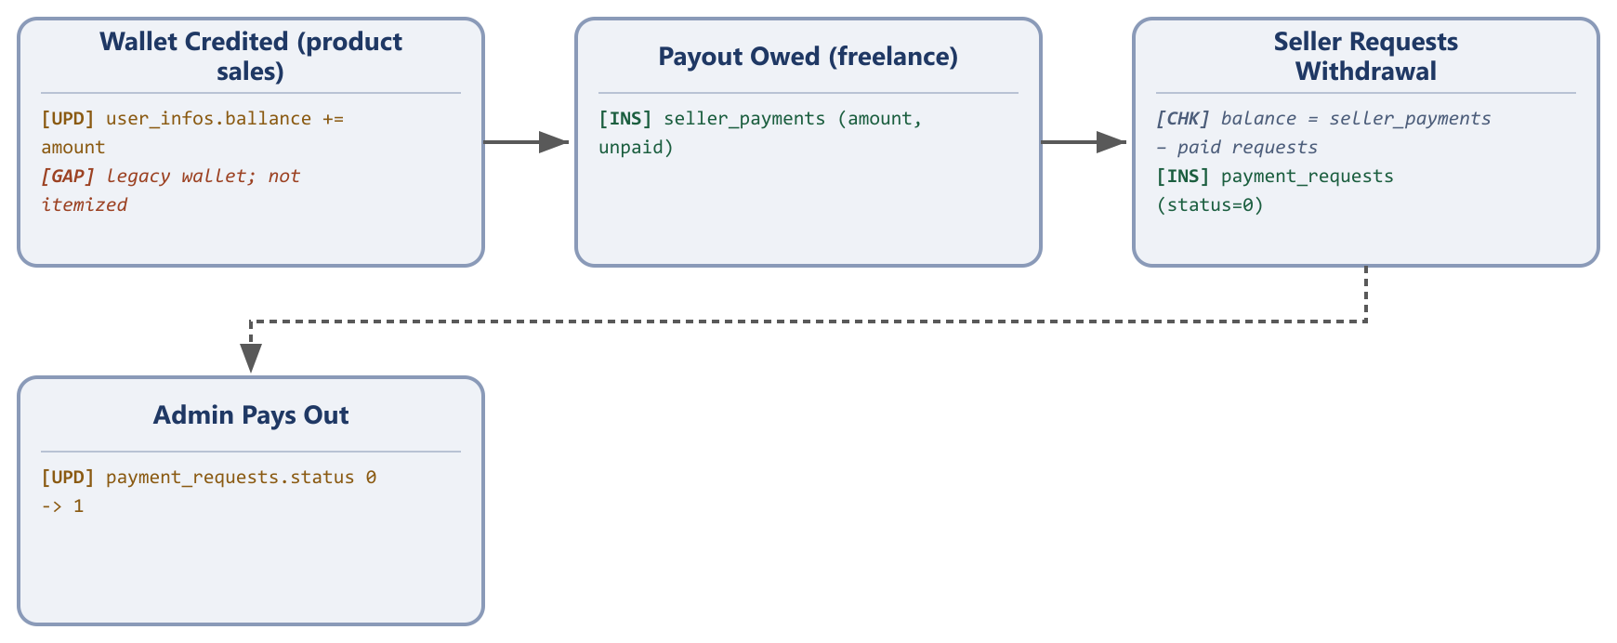

6.7 Professional profile
- Maintain a public profile with skills, education history, and work experience — particularly useful for freelance service sellers
Database tables involved: skills, interests, edcations, experiences

6.8 Notifications
- Receive in-app notifications when: a seller application is approved or disapproved; a new bid is received on a posted project; a hire is accepted, cancelled, or completed; a new order is received; an order is accepted or cancelled; and a payment is confirmed.
Database tables involved: notifications

7. Customer (Buyer) Panel — Actions
The Customer panel is the default experience for every registered account and covers browsing, buying, and hiring. Every subsection below has been re-checked against the source-level Customer/Buyer Panel Specification; its functionality list was already essentially complete, so this pass focused on adding database tables and process flows.

7.1 Account & discovery
- Register and sign in by email, phone (with OTP), Google, or Facebook
- Browse and search products and services by category, location, and listing format
- View seller profiles, ratings, and past reviews before buying
Database tables involved: users, user_infos, grand_categories/parent_categories/child_categories (read), service_grands/service_parents/service_children (read), otps, otp_logs, verifies

7.2 Shopping
- Add items to a shopping cart and a wishlist (“favourites”)
- Check out with a delivery address, delivery-cost calculation, and payment via Stripe (card) or bKash (mobile wallet)
- Submit a bulk-order inquiry to a wholesale seller for a custom quote
Database tables involved: carts, favourits, sales, shippings, orders, billings, delivery_costs, simple_reqs
Process flow — shopping and checkout:
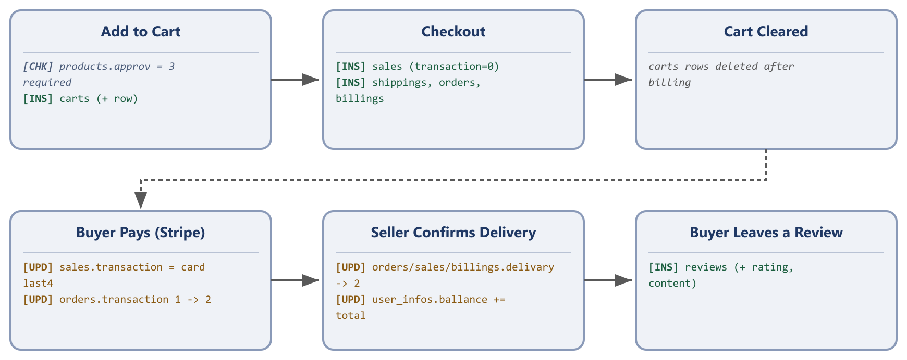

7.3 Hiring freelance help
- Hire a seller's listed service directly
- Post a project describing work needed, and receive competing bids from sellers
- Review bids and select a seller to hire
- Track progress and mark work as received/complete, releasing payment
Database tables involved: services, bid_for_services, hireds, service_orders, payments, hire_pays, order_pays

Path A — Hire a seller's listed service directly
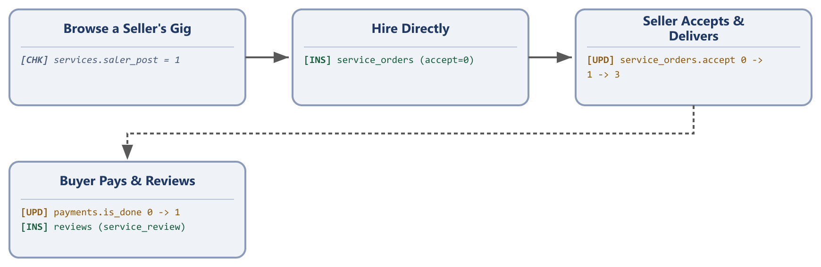

Path B — Post a project and receive bids
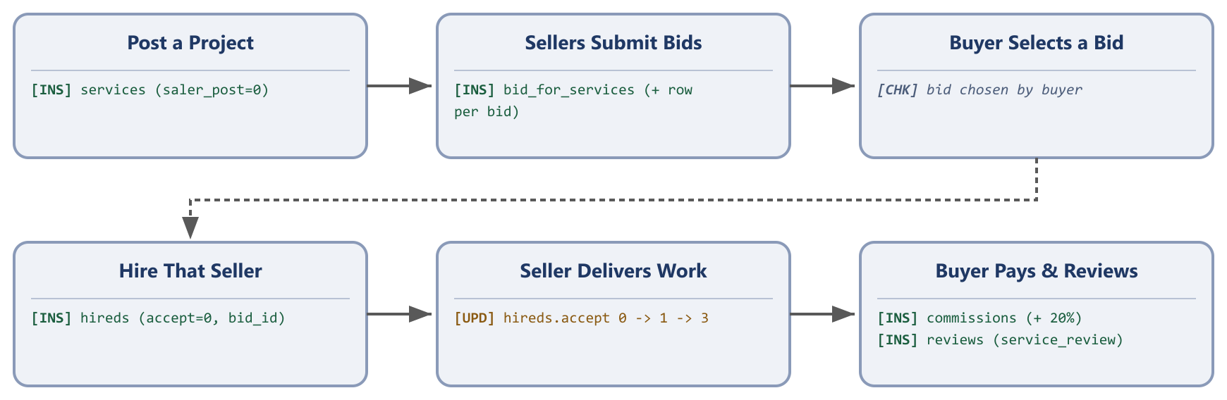

7.4 After a purchase
- Track the status of orders and service requests, and cancel where still allowed
- Chat with the seller about a specific order, product, or service
- Leave a rating and written review once an order or job is complete
- Request a refund through the wallet/balance system if eligible
Database tables involved: sales, orders, billings, chats, messages, reviews, balances, refund_histories
Process flow — after placing an order:
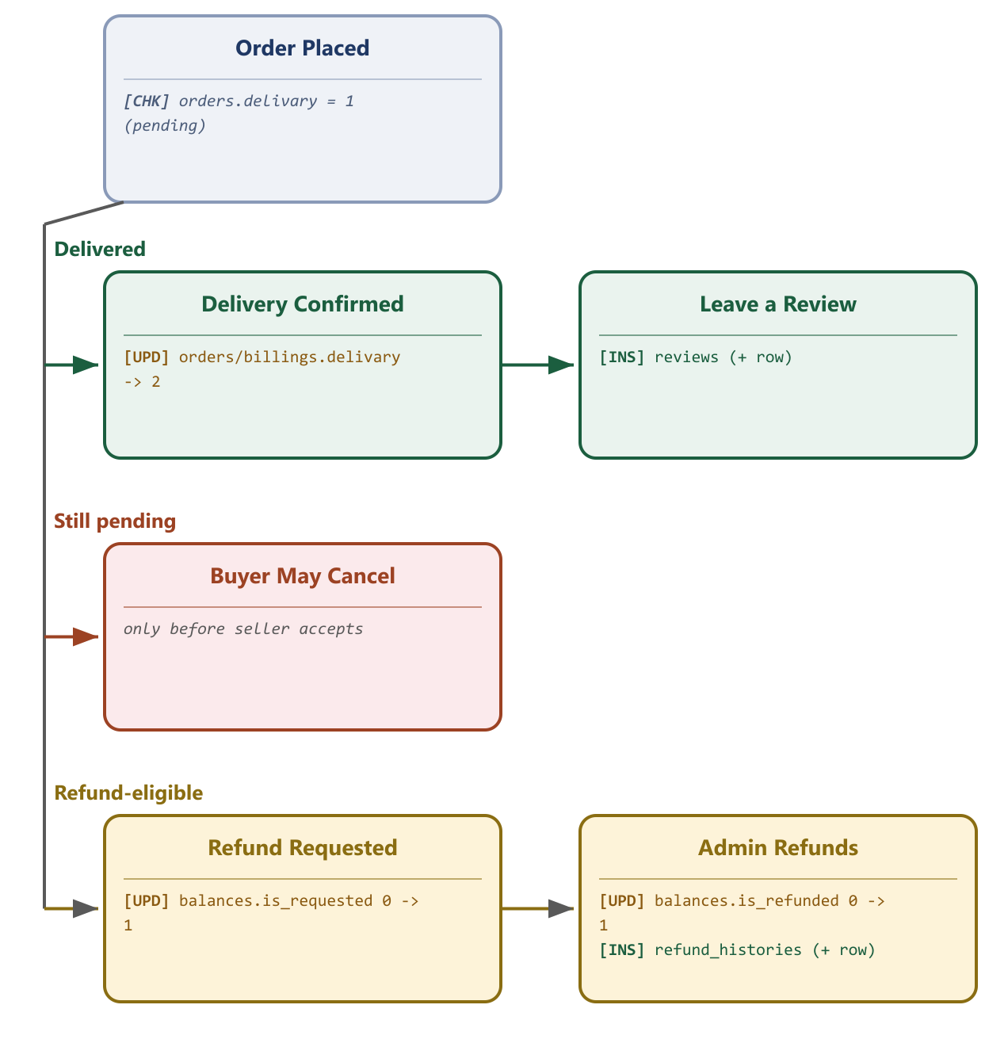

7.5 Account management
- Manage personal profile details and saved addresses
- View notifications for order updates, messages, and account activity
- Apply to become a Seller at any time
Database tables involved: users, user_infos, companies, contacts, notifications

8. Key Cross-Panel Workflows
The diagrams in Sections 5–7 show each role's own steps within a feature. The diagrams below show the same processes end-to-end, spanning every role involved, for a reader who wants the full journey in one place.

8.1 Seller onboarding & verification
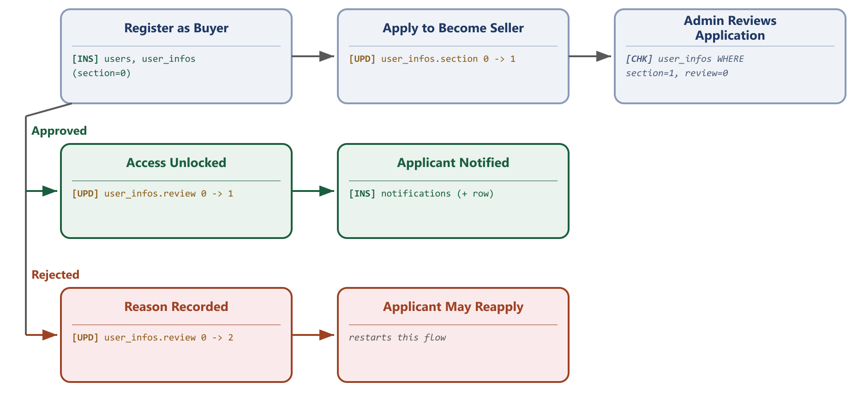

8.2 Listing approval workflow
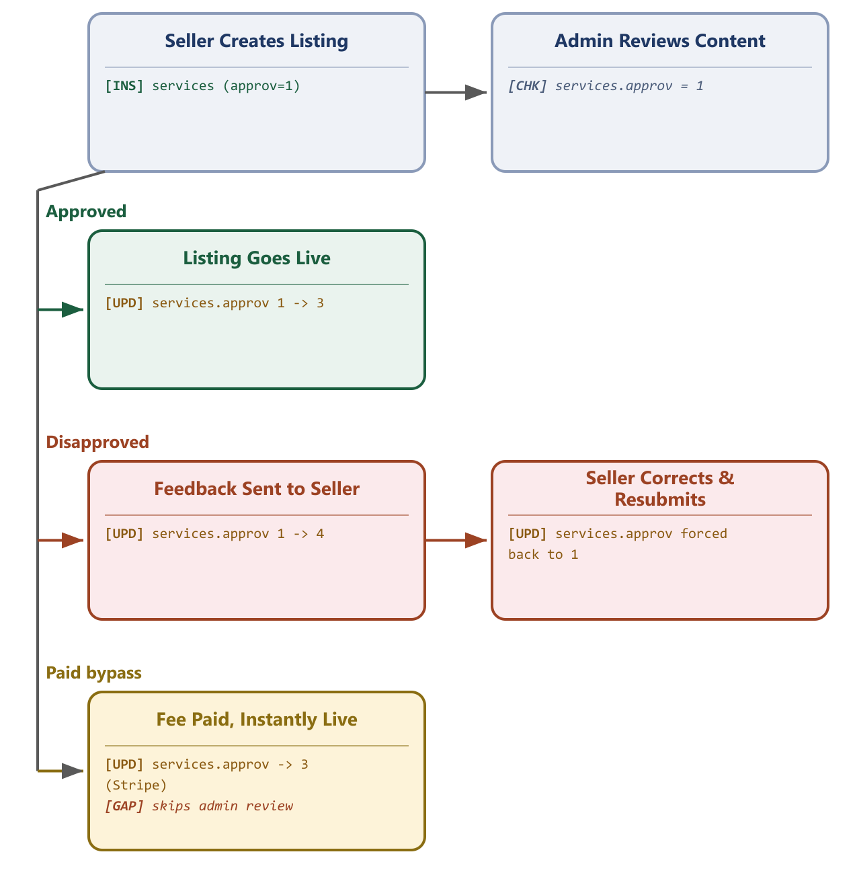

8.3 Product order & delivery
This is the same flow shown from the buyer's side in Section 7.2 — reused here because it already spans cart (buyer), checkout & payment (buyer), fulfilment (seller), and delivery confirmation (seller writes, buyer receives), so a separate cross-role version would only repeat it.


8.4 Freelance hiring & bidding
There are two paths into a freelance engagement:

Path A — Hiring a seller's listed service


Path B — Buyer posts a project and receives bids


8.5 Payments, commission & seller payout
Commission payment verification:

Earnings to withdrawal payout:


9. Current Implementation Status & Companion Technical Specifications
Following this overview, a full implementation-level technical audit was carried out across all three panels — reading the actual application source (routes, validation rules, database logic) rather than inferring behavior from the interface. That audit produced three companion documents, each detailed enough for a developer to rebuild the corresponding panel without further clarification:
- Egoola Admin Panel — Complete Low-Level Technical Specification
- Egoola Seller Panel — Complete Functional & Technical Specification
- Egoola Customer/Buyer Panel — Complete Low-Level Technical Specification
This section translates the most business-relevant findings from that audit into plain terms. It exists so that anyone reading this overview — not only the development team — has an accurate picture of what the platform reliably does today, versus what is designed but not yet fully working, or working in a way that carries risk. Full technical detail, including the exact defect and its fix, is in the relevant companion specification.

9.1 Security & data-integrity risks worth prioritizing
- Several account actions do not check who is asking. A number of freelance-order actions (accepting, cancelling, marking work done, and confirming payment on a directly-ordered service) do not verify that the person taking the action is actually the seller or buyer on that specific order. In its current state, this means one user could, in principle, affect another user's order, cart, wishlist, saved notification, or refund request simply by knowing or guessing its reference number. This is the single highest-priority item to close before scaling traffic or handling higher transaction volumes.
- Account registration does not fully enforce identity verification. The one-time code sent during sign-up is not, in every path, confirmed as entered correctly before an account can be created against that phone number or email — creating a theoretical account-takeover risk during registration that should be closed.
- The freelance category-management screens are not restricted to Administrators as intended. Any signed-in user can currently reach the screens meant to be admin-only for managing the freelance-services category list, including deleting entries — the goods category tree shown in Section 5.2's diagram does not have this problem, only the parallel freelance one.

9.2 Features that are designed but not fully working today
- Card payment for goods orders is not currently reachable in the interface. The checkout flow supports it in the backend, but the button that would start it has been disabled on the order page — so goods purchases can currently only complete via cash-on-delivery, not by card.
- The delivery-confirmation code does not reach the buyer. A one-time code is generated to let a seller confirm hand-off with the buyer, but the notification that would tell the buyer their code is currently switched off, and the code is not shown anywhere in the buyer's order view. As built, this confirmation step has no practical way to work unless the code is shared some other way.
- The freelance bid-submission form is not currently usable. Sellers can view a buyer's posted project, but the form to actually submit a bid on it is not present in the current interface.
- Two separate seller-payout systems exist side by side. An older, simple running-balance system and a newer, more structured withdrawal-request system both exist, were never fully merged, and the newer one's “how much can I withdraw” calculation contains an arithmetic error that can understate a seller's real available balance. These should be consolidated and corrected before being relied on for real payouts at scale.

9.3 Lower-severity gaps
- Search results can occasionally include listings that shouldn't be visible yet (still pending review) or that belong to a different browsing context (buyer vs. seller), due to how search filtering is currently combined with other conditions.
- Live chat and the in-app notification badge both require a page refresh to show new activity — they are not yet truly real-time, despite the underlying infrastructure for that being present.
- A handful of admin-editable settings and email templates (a website-title field, three of six email templates) are currently stored and editable but have no effect on what a user actually sees, because nothing in the code reads them.
- Reviews can, in some cases, be submitted before the underlying order is actually marked complete, since that check currently lives only in which screen shows the review button rather than being enforced consistently.

9.4 What this means going forward
None of the items above change what the platform is designed to do — the functionality described in Sections 3 through 8 remains the accurate target. What this section adds is an honest account of how completely today's build delivers on that design, so that decisions about launch readiness, continued development priority, and risk tolerance can be made with full information. The companion technical specifications give the development team everything needed to close each gap without having to rediscover it from the source code.

10. Summary
Egoola.com combines a multi-format goods marketplace with a freelance services marketplace inside one platform, connected by a shared account system, wallet, messaging, and review layer. A single Administrator panel keeps the catalogue, sellers, and money moving through the platform under review, while the Seller and Customer panels share the same underlying account, letting a user shop today and start selling tomorrow without creating a second identity.
This revision re-verifies every role's functionality against the three source-level technical specifications, adds the specific database tables behind every feature, and adds a low-level process-flow diagram — both from each role's own point of view (Sections 5–7) and as a full cross-role journey (Section 8) — for every feature that is a sequence of steps, with the exact table/column/value written at each step and every confirmed implementation gap called out directly on the diagram where it occurs. Section 9 records the platform's actual current implementation status per that same audit. Together with the three companion technical specifications, this gives a complete, accurate picture of the platform as designed and as built, sufficient to guide either continued development or a full rebuild.

